SDG Unit -2 Assignment
Multilayer Perceptron for Maternal Health Risk Prediction
Aligned with SDG 3 – Good Health and Well-being

Name: M S Mukilan

Reg No: 192412071

Course Code: ITA0609

Problem Statement
A Multilayer Perceptron (MLP) is to be designed to predict the maternal health risk level of a pregnant woman — classified as Low, Medium, or High risk — using three input features: Blood Pressure, Blood Sugar, and Age. This is a supervised multi-class classification problem. Early and accurate identification of high-risk pregnancies directly supports Sustainable Development Goal 3 (Good Health and Well-being), particularly the target of reducing maternal mortality by enabling timely medical intervention.

1. Network Architecture Diagram
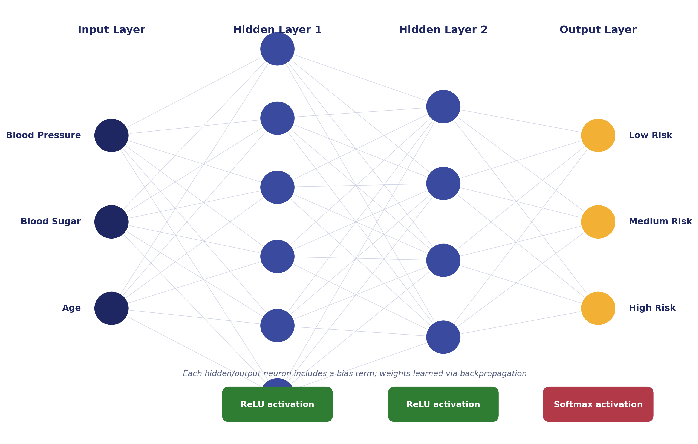
Figure 1: MLP architecture for maternal health risk classification

2. Explanation of the Architecture

2.1 Input Layer (3 Neurons)
The input layer has exactly three neurons, one for each input feature:
- Blood Pressure — typically represented as systolic/diastolic values or a normalized single value.
- Blood Sugar — fasting or postprandial glucose level (mg/dL).
- Age — age of the woman in years.
Before being fed into the network, all three features are normalized or standardized (e.g., min-max scaling to [0,1] or z-score standardization), since they have very different natural ranges (age in tens, blood sugar in hundreds). This prevents features with larger numeric ranges from dominating the learning process. The input layer itself performs no computation — it simply passes the (scaled) feature values forward.

2.2 Hidden Layer 1 (6 Neurons) — ReLU Activation
The first hidden layer expands the 3 input features into 6 neurons, allowing the network to learn a richer set of intermediate representations (combinations and interactions of blood pressure, blood sugar, and age).
Activation function: ReLU, f(z) = max(0, z)
- ReLU is computationally efficient and avoids the vanishing-gradient problem that affects sigmoid/tanh in deeper networks.
- It introduces non-linearity, which is essential because the relationship between clinical readings and risk level is non-linear (e.g., risk rises sharply only past certain thresholds of BP or sugar).

2.3 Hidden Layer 2 (4 Neurons) — ReLU Activation
A second hidden layer with 4 neurons further compresses and refines the learned representations, helping the network capture higher-level patterns before the final classification decision. ReLU is again used here for the same reasons as Hidden Layer 1: fast convergence and effective gradient flow.
The progressive narrowing (3 → 6 → 4 → 3) is a common design heuristic: the first hidden layer expands the feature space to capture diverse patterns, and subsequent layers gradually distill this into a compact representation relevant to the final classes.

2.4 Output Layer (3 Neurons) — Softmax Activation
The output layer has 3 neurons, one for each risk class: Low, Medium, and High.
Activation function: Softmax, applied across the 3 output neurons together.
Softmax converts the raw output scores (logits) of the three neurons into a probability distribution that sums to 1, so each neuron's output represents the estimated probability that the input belongs to that particular risk class. The class with the highest probability is chosen as the predicted risk level. Softmax is the standard choice for the output layer whenever the classes are mutually exclusive (a patient is in exactly one risk category), as is the case here.

3. Loss Function and Training
- Loss function: Categorical Cross-Entropy — appropriate for multi-class, single-label classification with a softmax output.
- Optimizer: Adam or Stochastic Gradient Descent (SGD), used to iteratively update weights and biases.
- Learning algorithm: Backpropagation computes gradients of the loss with respect to every weight, layer by layer from the output back to the input, and the optimizer adjusts the weights to minimize the loss over training epochs.
- Regularization: Techniques such as dropout or L2 weight decay may be added between hidden layers to reduce overfitting, since maternal health datasets are often limited in size.

4. Summary of Architecture
Layer | Neurons | Activation | Purpose
Input Layer | 3 | None (linear pass-through) | Receive BP, Blood Sugar, Age
Hidden Layer 1 | 6 | ReLU | Learn non-linear feature combinations
Hidden Layer 2 | 4 | ReLU | Refine and compress representations
Output Layer | 3 | Softmax | Output class probabilities (Low/Medium/High)

5. Relevance to SDG 3 – Good Health and Well-being
Maternal mortality remains a major global health challenge, and SDG 3 specifically targets reducing the global maternal mortality ratio. An MLP-based risk classifier built on easily measurable indicators — blood pressure, blood sugar, and age — can be deployed in primary healthcare centers, especially in resource-limited settings, to:
- Flag high-risk pregnancies early so that patients can be referred for specialized care before complications arise.
- Support healthcare workers with a low-cost, data-driven decision aid where specialist obstetricians may not be readily available.
- Enable continuous monitoring and triage, improving the efficient allocation of limited medical resources toward the patients who need them most.
In this way, a well-designed neural network architecture directly contributes to timely intervention and improved maternal health outcomes, supporting the broader goals of SDG 3.

